1. Adicionar dependencias (spring-security-web e spring-security-config)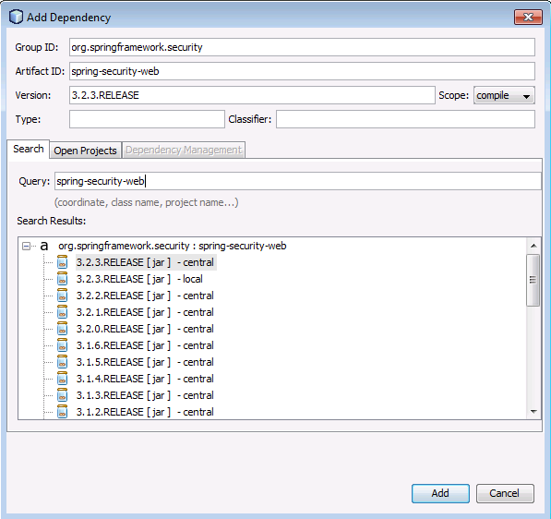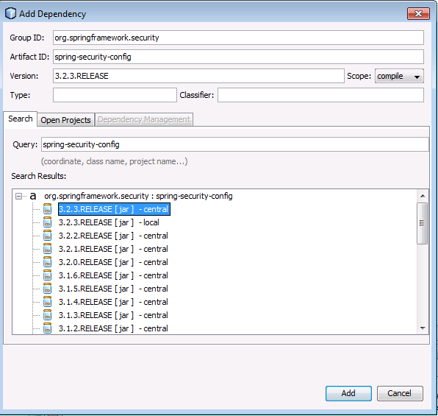
2. Adicionar class SecurityConfig:

package com.altran.lab.spring.security;

import org.springframework.beans.factory.annotation.Autowired; import org.springframework.context.annotation.\*;

import org.springframework.security.config.annotation.authentication.builders.\*;

import org.springframework.security.config.annotation.web.configuration.\*; @Configuration

@EnableWebSecurity

public class SecurityConfig extends WebSecurityConfigurerAdapter {

@Autowired

public void configureGlobal(AuthenticationManagerBuilder auth) throws Exception {

auth  
.inMemoryAuthentication() .withUser("user").password("password").roles("USER");

}

}

1. Adicionar class SecurityWebApplicationInitializer:

package com.altran.lab.spring.security;

import org.springframework.security.web.context.\*;

public class SecurityWebApplicationInitializer extends AbstractSecurityWebApplicationInitializer { }